| **Step** | **Element** | **Description** |
| --- | --- | --- |
| **Entry Point** | **Client Meeting Prep → “Launch Note” Button** | Banker is reviewing the prep brief for an upcoming client call (e.g., ServiceNow M&A). They click **“Launch Note”**, which opens the contextual note-taking view in the split screen. |
| **1** | **Auto-Load Pre-Context** | Prep brief details (company profile, last note, deal status, prior valuation signals) are loaded in a **read-only left pane**. The **right pane** is a fresh note canvas. |
| **2** | **Live Note Capture** | User begins taking notes:• Typed manually• Drag-and-drop transcript• Pull from meeting platform (Zoom, Teams) |
| **3** | **Context-Aware Enhancements** | As banker types, smart prompts emerge:• “Tag valuation anchor?”• “Track sentiment shift?”• “Flag buyer constraint?”Banker controls AI suggestions. |
| **4** | **Smart Summary + Timeline Anchor** | After call ends, the app auto-generates:• Key Points• Sentiment Tracker• Timeline updates• Context tags (e.g., “Valuation moved from 2.2x → 1.9x”) |
| **5** | **Threaded Integration** | Note links back to:• Client’s deal timeline• CRM record• Prior meetings |
| **6** | **Next Action Prompt** | “Prep next meeting?” → Brings forward relevant threads and suggests new objectives. |

### Step 1: AutoLoad Pre-context – Detailed Scenarios

#### Scenario A: User launches the note *before* the call starts

* **Use Case**: The banker opens the note canvas 5–10 minutes before the meeting begins.
* **Behavior**:  
  + The system loads the **prep context** and applies a **template** based on the meeting type (e.g., “Origination”).
  + Note canvas is in **edit mode**, with no live transcription.
  + A passive indicator appears: *“Meeting starts in 7 minutes. Transcription will activate when call begins.”*
  + User can pre-fill: agenda items, talking points, expectations.

✅ This mode supports proactive bankers who plan ahead and want to sketch talking points before the discussion starts.

#### Scenario B: User launches the note *after* the call has started

* **Use Case**: The call is already in progress; user clicks "Launch Note."
* **Behavior**:  
  + System detects the active Zoom/Teams/Webex meeting.
  + Loads meeting prep context + current call metadata.
  + **Live transcription begins immediately**, timestamped to call start.
  + The note canvas shows a visual indicator: *“Capturing from 2:07 PM — synced with transcript.”*

✅ This is for users who delay opening notes but still want full capture and context alignment.

#### Scenario C: Call begins, but user hasn’t launched notes yet

* **Use Case**: User forgets to launch note manually.
* **Behavior Options** (depending on product decision):  
  + **(a) Passive Transcription Mode**: System auto-captures the transcript silently in the background.  
    - Later prompts: *“Missed the note? Click here to reconstruct from today’s call.”*
    - Gives option to retro-tag conversation flow into the appropriate structure.
  + **(b) No auto-capture**: Warns user post-call: *“No note was launched. Would you like to generate one from meeting transcript?”*

🔄 Trade-off between compliance/privacy defaults vs. usability — we recommend (a) for trusted enterprise clients with secure integrations.

### 🔄 Optional Enhancements

* “🧠 **Pre-fill Mode**”: Lets users jot thoughts pre-call. Becomes read-only once call starts and switches to live mode.
* “📡 **Live Sync Mode**”: Follows transcript in real-time and nudges user with tag suggestions mid-call.
* “🕒 **Missed Call Catch-up**”: If no note was launched, it still reconstructs from transcript afterward.

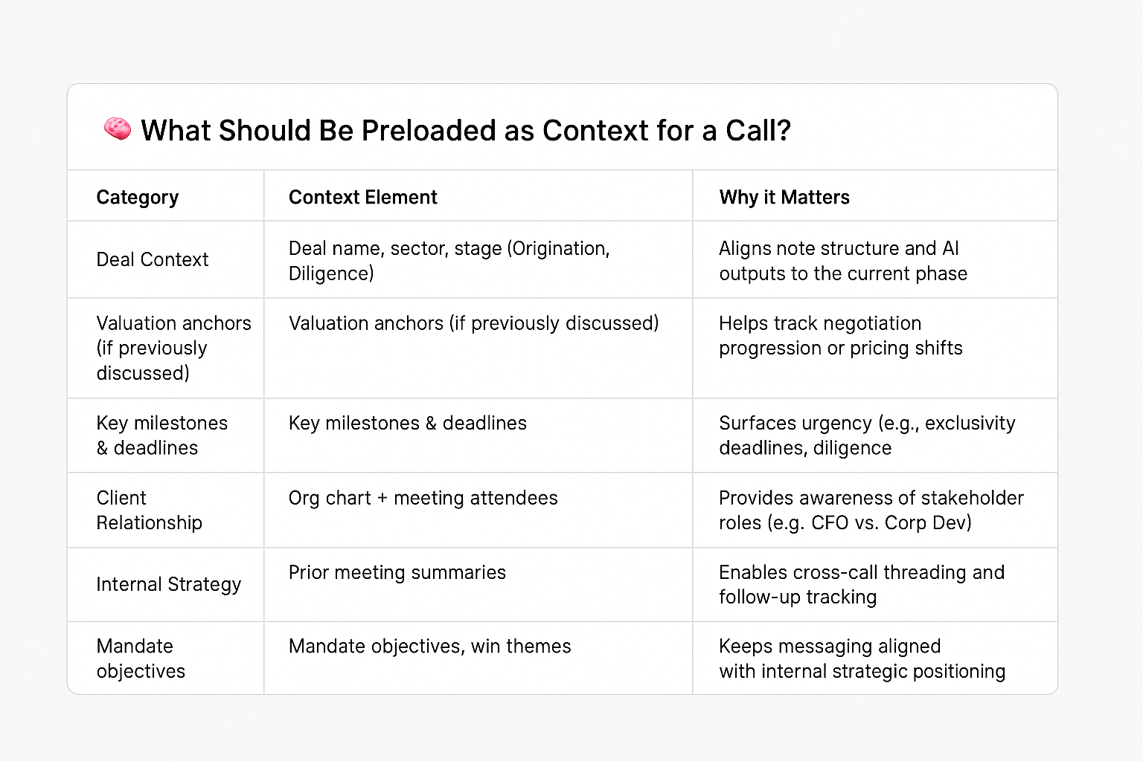

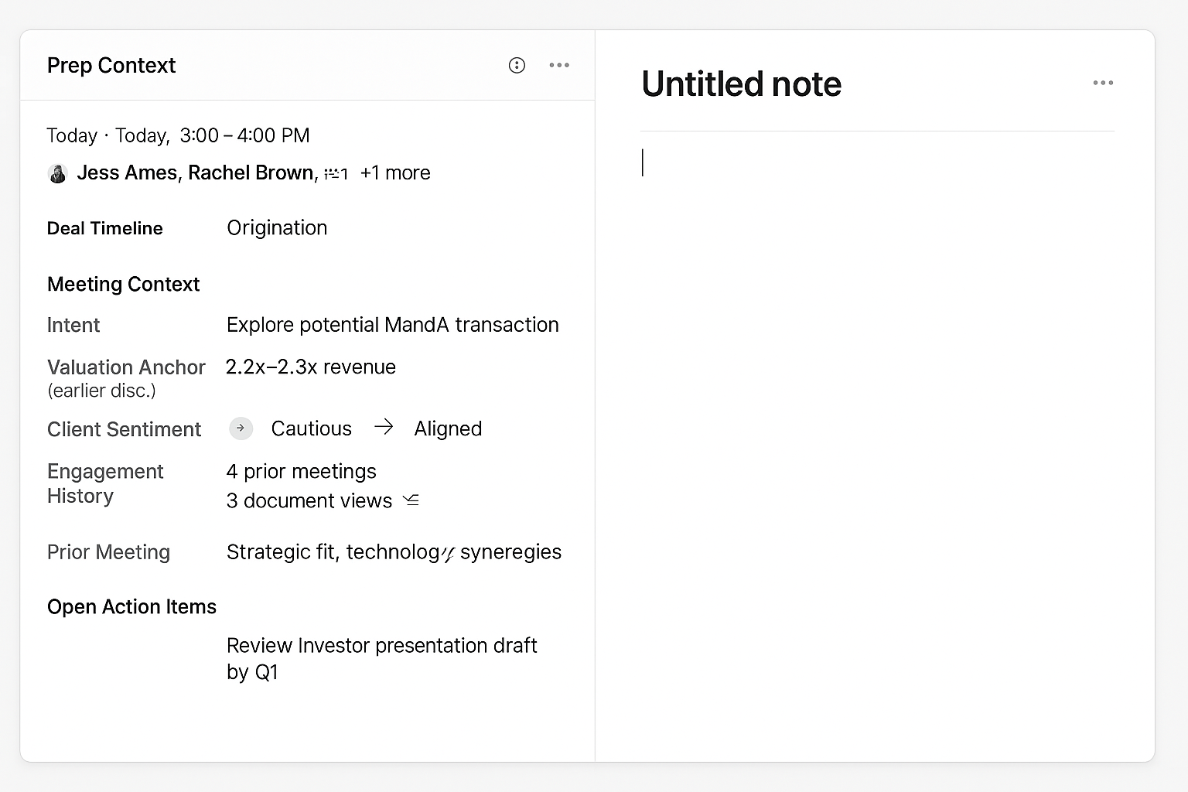

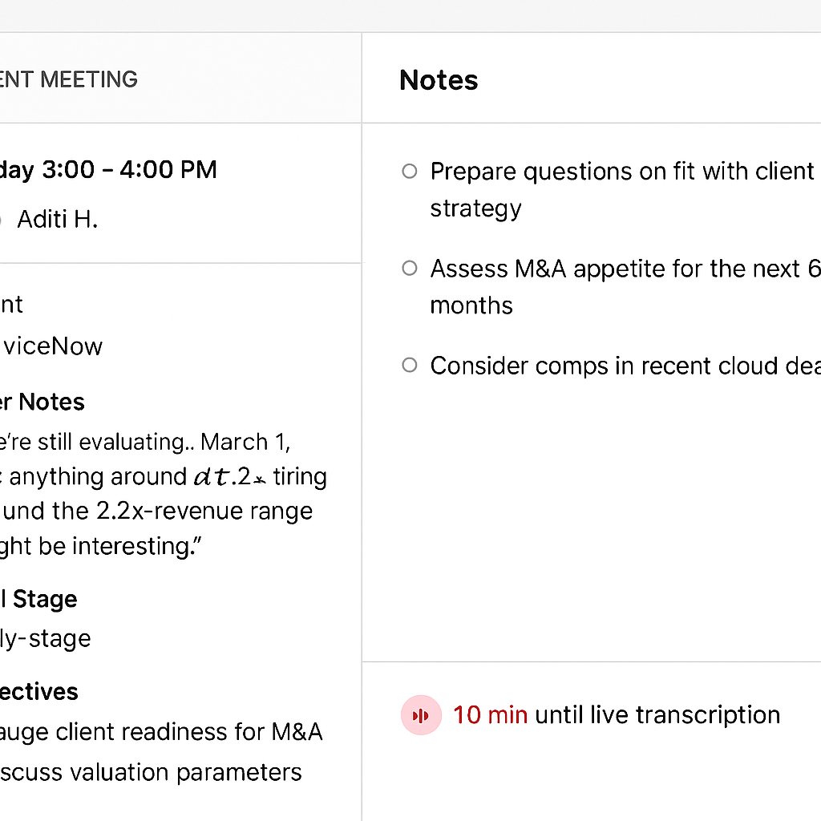

Let the user stay in the **Client Meeting Prep + Note** interface **as the Zoom meeting begins**, without jumping back to Outlook or Zoom manually — unless they want to.

## ✅ Ideal Live Note Capture Flow (Minimal Disruption)

### 📍 10–5 mins before meeting:

* Banker opens **Client Meeting Prep** tool inside CRM or platform.
* They click **“Launch Note”**, review context, maybe pre-fill talking points.

### 🚨 As the Zoom meeting starts:

* **One of two things happens**:  
  + **Option A: Embedded Zoom** If supported by IT, Zoom launches **in a split panel** on the right or bottom (like a minimized call widget).  
    - Note panel stays open
    - Banker never switches tabs
    - Audio/video captured for transcript
  + **Option B: External Zoom, Internal Sync** If Zoom runs separately (most common), the system:  
    - Auto-detects when Zoom starts (via calendar or Zoom API)
    - Triggers **transcription to start**
    - Keeps banker in the note canvas
    - Shows subtle banner: *“Recording from Zoom in progress”*

### 🟢 Live note capture view:

* Banker types in real time (or not)
* System overlays inline suggestions:  
  + “Capture Valuation Anchor?”
  + “Sentiment Shift Detected”
* Transcript appears in background or as a side tab

## 🔌 Supporting Integrations Required

| **Integration** | **Role** |
| --- | --- |
| **Zoom Calendar SDK or Webhook** | Detect meeting start, pull transcript, link metadata |
| **Outlook Add-in or OAuth** | Auto-join detection, launch prep + note view from calendar |
| **Optional: Zoom App SDK** | Embed Zoom UI inline if bank permits (nice to have) |

## Interaction Detail: Live Note Capture (During Meeting)

| **Time / Moment** | **What the Banker Does** | **System Behavior** | **Live Meeting Status Icon (UI)** |
| --- | --- | --- | --- |
| **10 min before** | Opens *Client Meeting Prep* → clicks **Launch Note** | Loads prep context in left panel + note canvas on rightShows meeting countdown | ⏳ Grey dot“Meeting starts in 10 minutes” |
| **2 min before** | (Optional) Reviews talking points / pre-fills note | Adds subtle CTA to open Zoom | ⏳ Yellow pulse“Meeting starting soon”🔘 Open Zoom |
| **30 sec before** | Opens Zoom via Outlook invite | Detects Zoom via metadata/calendar sync | 🔄 Detecting…“Matching call to prep session…” |
| **Call time** | Focused in Zoom (note app may stay open or minimized) | Confirms Zoom matchPreps for transcription start | 🔴 Red pulse“Zoom detected — transcription starts soon” |
| **Transcription begins** | — | Background transcription begins silentlyPrep thread is updated with call metadata | 🔴 Red waveform“Recording in progress” |
| **During call** | Optionally toggles to notes; types manually or reviews context | Insight Timeline Strip begins collecting real-time AI nudges (valuation, sentiment, urgency, etc.) | 🔴 Red icon stays activeWaveform pulses gently |
| **AI nudges detected** | — | Nudges appear in Insight Timeline:• Add to note• Edit• Dismiss | No popups — nudges appear in side timeline only |
| **After call** | Returns to review AI suggestions + finalize notes | Auto-generates summary, tracks sentiment deltas, offers “Next Action” prompt | ✅ Green checkmark“Meeting complete — review summary” |

## Context-Aware Enhancements (AI Nudges During Call)

AI listens passively and logs signals without showing the transcript. Nudges appear as a **timeline of AI insights**, not pop-ups.

### ✅ Unified Nudge Experience: Insight Timeline Strip

* 📌 **Location**: Fixed side panel on right
* 🔁 **Behavior**: Accumulates AI insights in real-time, with clear icons, timestamps, and action buttons
* ✍️ **User can**:  
  + Add an insight into the note with one click
  + Edit suggested text
  + Dismiss irrelevant insights

### ✨ Example Timeline Entries (during call):

pgsql

CopyEdit

🧠 [10:03 AM] Valuation anchor detected → 1.9x (↓ from 2.3x)

➕ Add to Notes ✏️ Edit ✖️ Dismiss

👤 [10:04 AM] Salman: “Client now pushing for exclusivity – use this for negotiation framing”

🧠 [10:06 AM] Sentiment shifted: exploratory → committed

➕ Add to Notes

## ✅ Design Principles

| **Risk** | **Resolution** |
| --- | --- |
| Too much noise from transcript | Transcript hidden by default; timeline entries are summarized signals |
| Confusion between AI vs human input | Visual labels, icons, and interactivity affordances differentiate clearly |
| Lost signals if not acted on | Timeline persists through and after call — banker can review async |

## Generated image